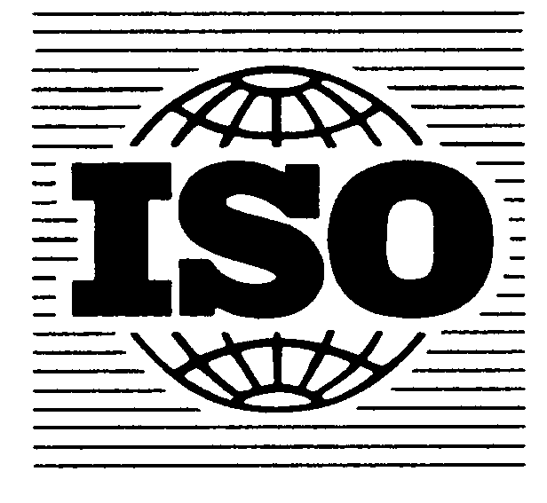 Document ISO/TC 147 N 892
Document ISO/TC 147/SC 2 N 1947
Document ISO/TC 147/SC 2/WG 72 N 55

Date: 2019-11-11

Water quality — Determination of cyclic volatile methylsiloxanes in water –Part 2: Method using Liquid –Liquid extraction with gas chromatography-mass spectrometry (GC-MS)

Registration form
for participation in the 3rd interlaboratory trial
 | Yes | No
I would like to participate in the interlab trial (Participation is free of charge)

Contact person
Company name
Address

Country
E-mail
Phone
Fax
Date, Signature

Please return the completed registration form by 15 December 2019 to:

Contact details of the Interlab organiser:

Jeremy Durham
Dow Chemical
MIOPS BLDG 1803, Midland MI 48674, USA
phone: +1 989.496.3182
fax: +1 989.496.5595
e-mail: jeremy.durham@dowcorning.com

